ECE 313 Lecture Notes
Lecture 5 on Sampling & Reconstruction Part 2
Thursday, September 29, 2026
By TA Alice Liu
…
Audio effects: TV Girl - cigarettes out the window first 15 seconds (suggested by a Fall 2026 student)
…
Midterm #1 on Thursday, Oct. 1, 11am to 12:15pm. Open book/notes/laptop. No networking and no AI tools. More info at end of notes. See midterm #1 page for more info.
…
Sampling Theorem – Recap
- Oversampling (no aliasing) according to Sampling Theorem ($f_{s}>2f_{max}$)
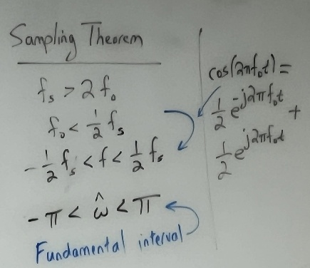
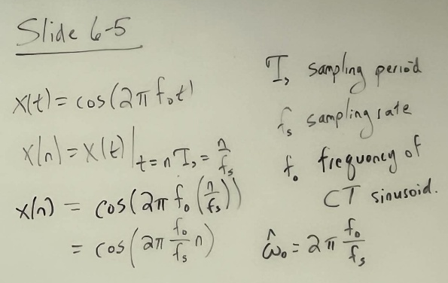
  - Enables perfect frequency reconstruction for conversion between Continuous Time and Discrete Time
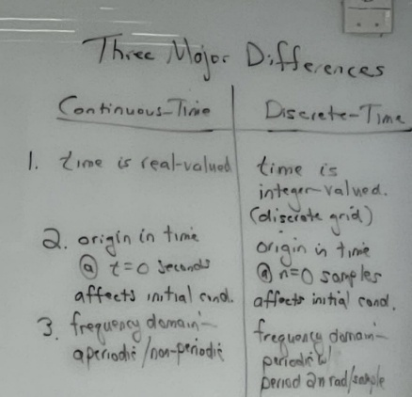
  - Note: Even without aliasing, the spectrum still replicates! (Due to Sampling)
    - Thus, we must disregard frequencies that are outside the range defined by the Sampling Theorem

- Undersampling (aliasing – no folding) ($f_{s}≤2f_{max}$)
  - We see the aliased frequency components instead of the desired signal frequency components
  - We don’t sample fast enough, and so the reconstructed signal’s frequency does not match the desired signal’s frequency
- Undersampling (aliasing – with folding) ($f_{max}<f_{s}≤2f_{max}$)
  - Special case of Undersampling (aliasing – no folding)
  - In this case of aliasing, we see the positive & negative frequency components swap places (or change sign)
  - Positive frequency -> shift graphically to the negative frequencies
  - Negative frequency -> shift graphically to the positive frequencies
…
Discrete to Continuous Conversion (Signal Reconstruction from Samples)
- Interpolation is a sum of weighted pulses
- Interpolation types
  - Rectangular (sample and hold)
  - Triangular (linear)
  - Sinc pulse (this is NOT sine/cosine sin function!)
    - Sinusoidal signal
    - Decays over time
    - Sinc pulse is very important going forward in the course
…
In-class DSP First Reconstruction Demo
…
Midterm #1 logistics/review
- See the midterm #1 page for more info.
- ZIP file of all content on Canvas made available to students later this afternoon
  - Students will have local copy of all course material
- Midterm example walkthrough (Midterm #1 Fall 2025 Problem 1.3)
  - Discuss expectations of work to show
  - Discuss awarding of partial credit
  - Discuss usage of MATLAB on the exam (not required)

